Catalogs
Catalog configuration object is intended for managing data lists. For example, each company has lists of employees (even if a company has only one employee), clients, products, and so on. A catalog consists of items. For example, an employee is an item of the Employees catalog, while a product is an item of the Products catalog, and so on. Users can add catalog items, which can include adding new employees, creating new products, or entering new customers.
What tasks does the catalog help to solve?
Catalogs are used when it is necessary to ensure consistent information input. Let's say our organization has hired a John Doe employee for a junior developer position. This fact must be reflected in the accounting system by the personnel document. After some time, it was decided to promote him to a middle developer. We need to enter a personnel document in order to reflect the fact of a change in position (and the amount of payment). But what if there's more than one John Doe in our organization? We must choose the right one, otherwise we can incorrectly calculate the salary of both employees. For this purpose, the employee in the personnel document is selected from the list of all employees, and not just entered in text. Each catalog item is unique and is associated with a record of a table, that stores data for that catalog.
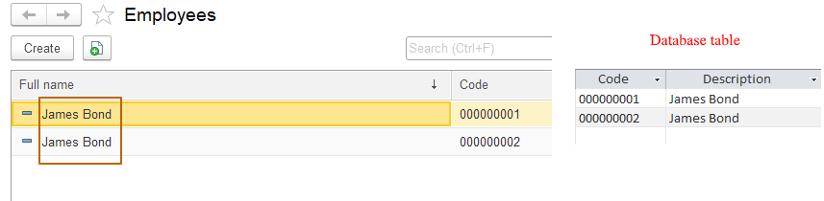
Catalogs store additional information about objects. We may need to store information about the date and place of birth of employees, weight of products, contact information of clients, and so on. To store such data, attributes of a Catalog metadata object are used, which are also configuration objects. Sometimes it is necessary to be able to store certain information in multiple form. For example, we want to store information about all the children of an employee in order to give them gifts on their birthdays. For such purposes we use tabular sections of objects (which are also configuration objects). These configuration objects (attributes and tabular sections) are subordinate to a particular catalog and stored at database with it*.

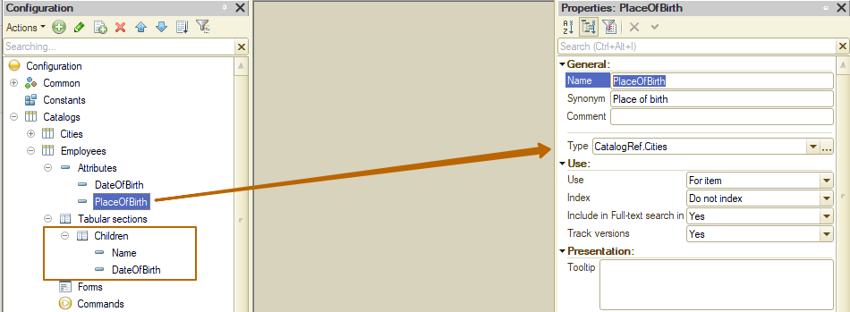
As you can see, one catalog contains a reference to another catalog in one of the attributes.
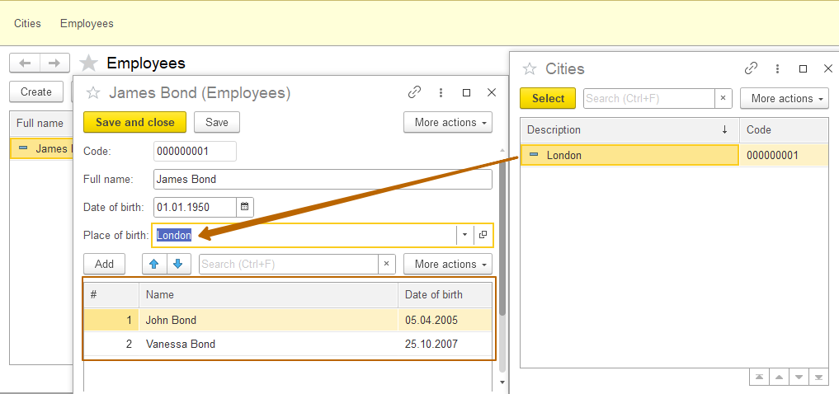
We can enter several rows in the tabular section to store the information of the same type.
* Tabular sections are stored at different tables from a catalog’s table. Each tabular part corresponds to a database table, which is associated with a catalog’s database table by a key field.
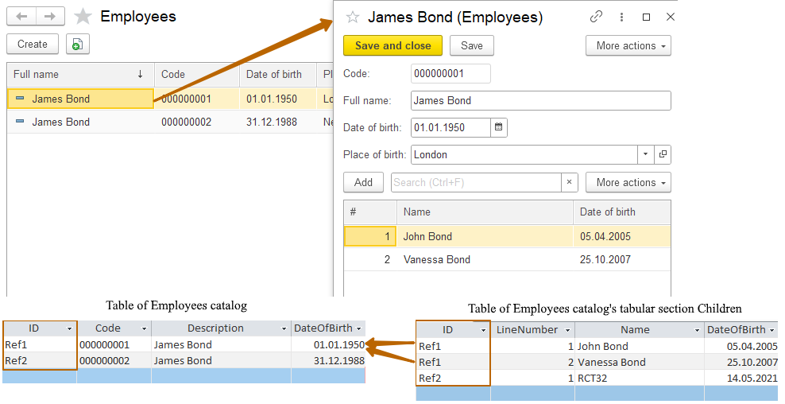
Attributes and tabular sections are added by the developer. But there are also standard attributes that are common within a metadata class. For a catalog these attributes are:
- Ref (reference to an object)
- Code (code of an item, can be turned off)
- Description (description of an item)
- Owner (contains reference to an item’s owner if a catalog is subordinated to another metadata object*)
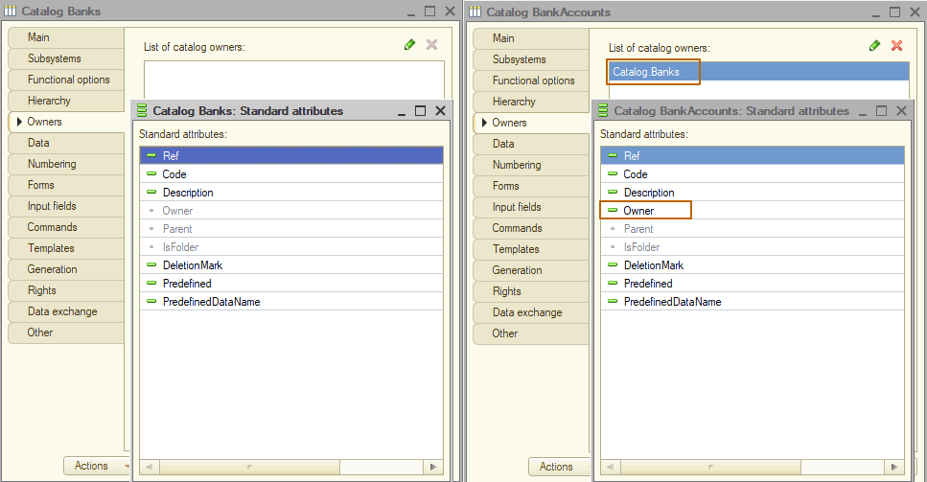
- Parent (contains reference to an item’s parent if a catalog is hierarchical*)
- IsFolder (an indicator of whether the object is a group or an item of a catalog if a catalog is hierarchical*)
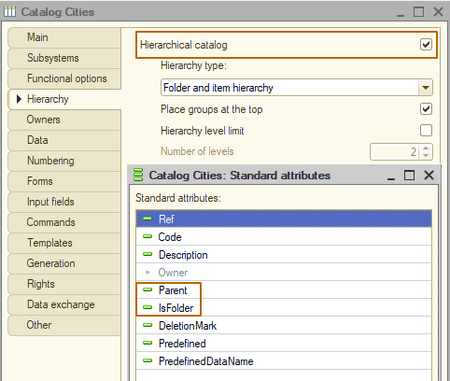
- DeletionMark (an indicator of whether the object is marked to deletion)
- Predefined (an indicator of whether the object is associated with a predefined item*)
- PredefinedDataName (name of the predefined item that the object is associated with*)
* We will take a closer look at subordinate and hierarchical catalogs, as well as at predefined items, in one of the next lessons.

Forms
Let's take a look at the catalog forms. A Catalog may have forms:
- Item (used to edit or create a catalog’s item)
- Group (used to edit or create a catalog’s group. Usually a group contains much fewer attributes and settings, so it is better to use a form separate from the item’s form to work with it. Only for hierarchical catalog)
- List (used to display a list of catalog’s items)
- Choice (used to select one or more catalog items. Similar to the list form, but usually contains less information, because it is not needed in process of selection. Sometimes one form can perform the functions of a list and a choice forms)
- Group selection (used to select a group of a catalog, not its item. Only for hierarchical catalog)
- Generic (used for any purposes)
The default form is the form that will be used for the corresponding action. For example, on opening a catalog item, the default item form will be used by Platform. If a catalog contains an item form, but it is not assigned a default form, the platform will not use it, but will dynamically create a new one (in enterprise mode, not in the designer).
Why then create your own form, if the platform is able to create forms itself? A custom form is created to change the design, as well as add new or change the standard logic.
Forms can be created using the form constructor. At the first step, the constructor allows us to select the form type, whether it should be assigned as the default form for the specified type, set the name, synonym and comment for the form. At the second step, we can select the elements that will be placed on the form, as well as the number of columns in which these elements should be placed.
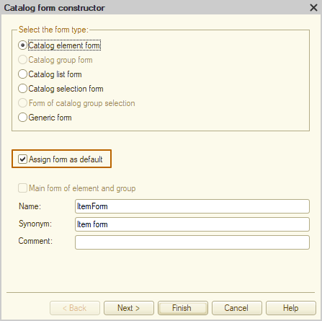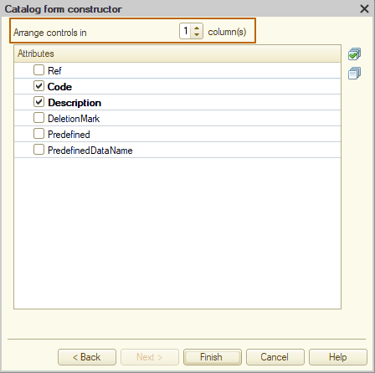

Representation in the interface
When building an application's interface, we typically want configuration objects to be grouped and ordered based on their purpose. Metadata class “Subsystems” are used for this purpose in 1C. We will not consider this object in detail now, a separate lesson will be devoted to it. Now I'll just create an HRM subsystem, in which I will add my catalog.
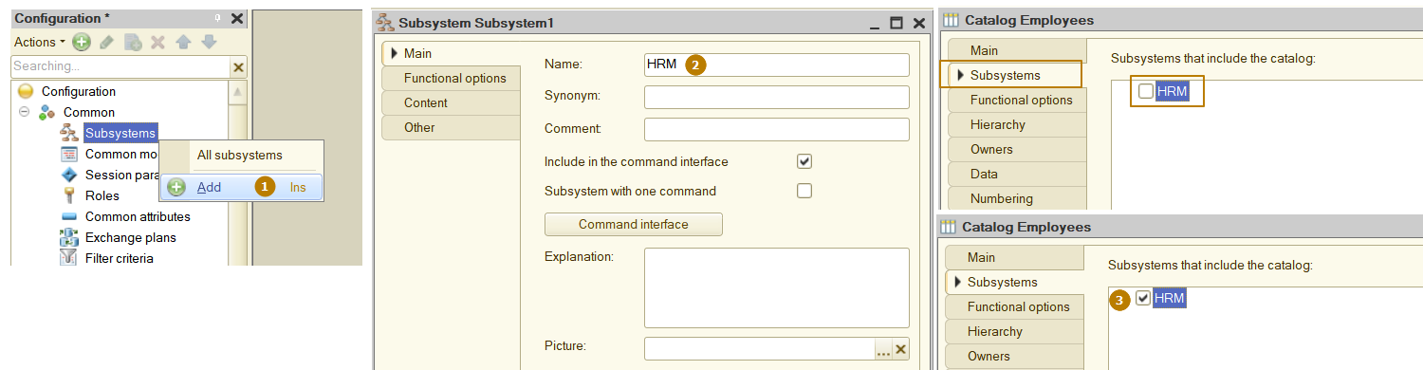
Now let's see how the application interface has changed. This requires updating the database configuration. When I tried to update, the following error occurred:
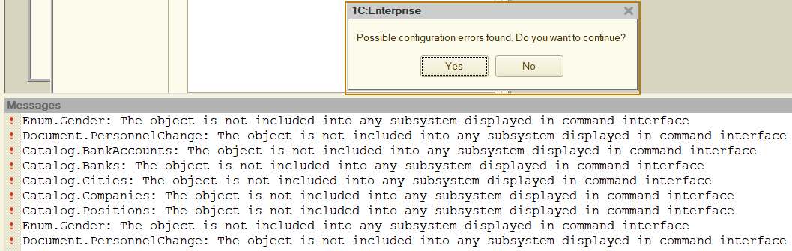
The fact is that after at least one subsystem has appeared in the system, the system checks that each configuration object belongs to any subsystem. You can continue updating by clicking the Yes button, but it is better to distribute all objects to subsystems. I will create another subsystem Bank and distribute all objects among the two subsystems.
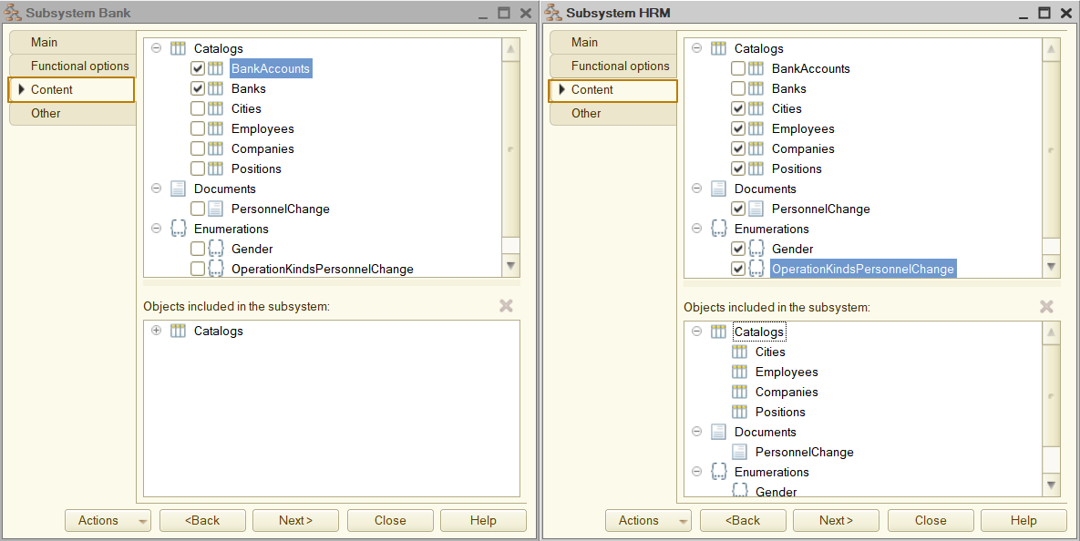

This is what the interface looked like before creating subsystems:
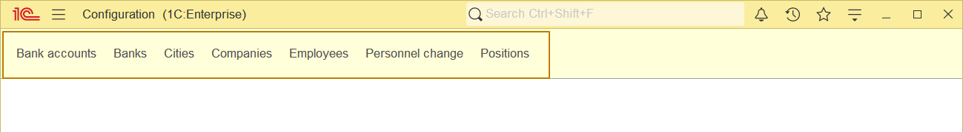
This is what it looks like after:
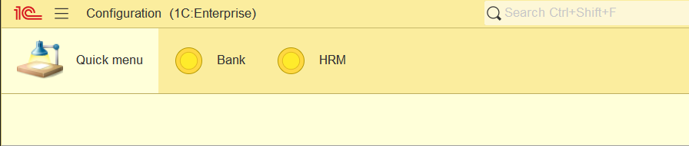
You can see that "sections" containing configuration objects have appeared. There is also a "Quick Menu" section, which we'll look at in one of the next lessons about the interface.
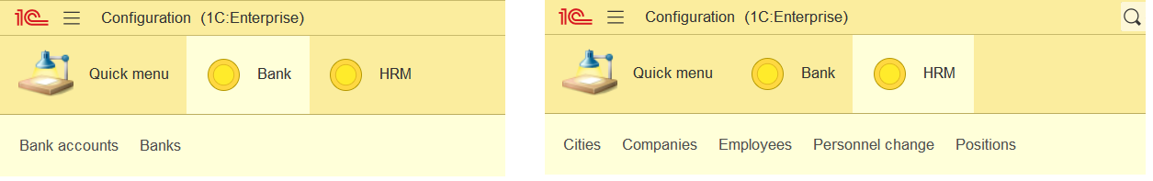

“Object presentation” defines the name of the object in the singular and is used in the name of a standard command, for example, the object creation command - Client: create.
“Extended object presentation” is used to represent a single object in a form, so it can be used for setting catalog item’s form title. In this case, if the extended object representation is not filled, object representation will be used.
“List presentation” is used in the name of a standard command, for example, the list of objects opening. This property should be filled when the object synonym is given in the singular (for example document Sales order, but command of opening list of objects should look like “Sales orders” or “Sales order list”).
“Extended list presentation” is used for the title of the list form. If the extended list presentation is not filled, the list presentation will be used.
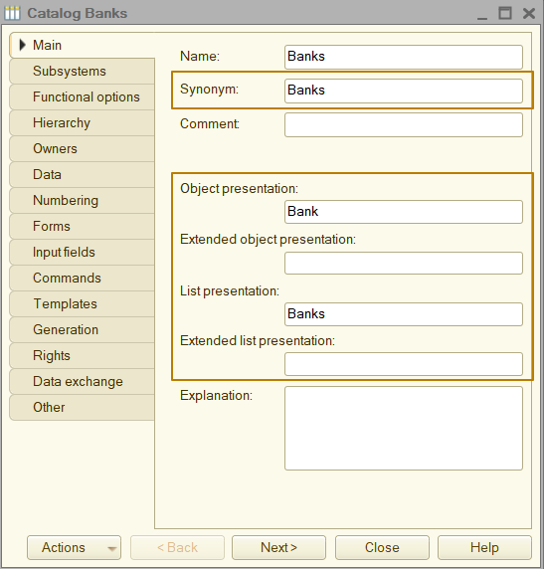

Enumerations
Metadata object Enumeration (Enum) is used to store a constant set of values that cannot be changed by a user. Why might this be needed? For example, to store tax rates that determined by tax laws of a country. It might be helpful for separating products by type: product, service, material. Or to store employee’s gender: male, female. We don't want to give a user the ability to add their own values to these lists, because some algorithms can be built based on it.
Let's create a Gender enumeration and add an attribute with this type to the Employees catalog and to its tabular section Children. I set the “Display error” value in property Required field so that the application would check the filling of this attribute on writing a catalog’s item.
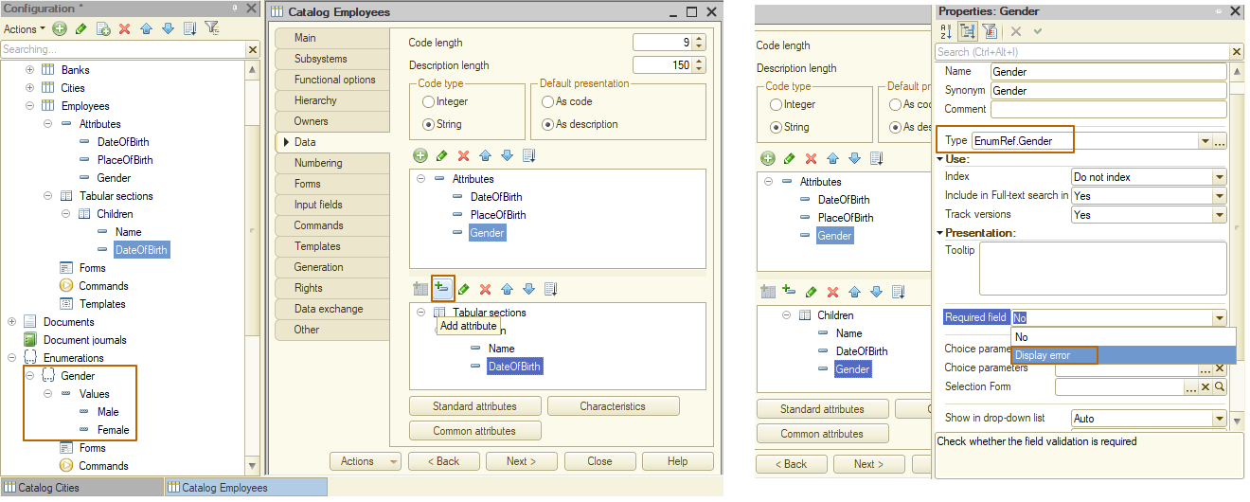

Let's take a look at the form of an Employee in Enterprise mode. This is how the selection of an enumeration’s value looks like - the list is fixed and there is no way to add a value or open a list form for selection from it.
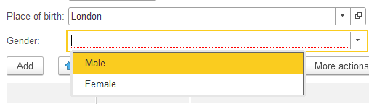

Since we noted the need to fill in the attribute Gender, the platform highlights the empty fields with color, and also does not allow the item to be written, displaying message with an error.
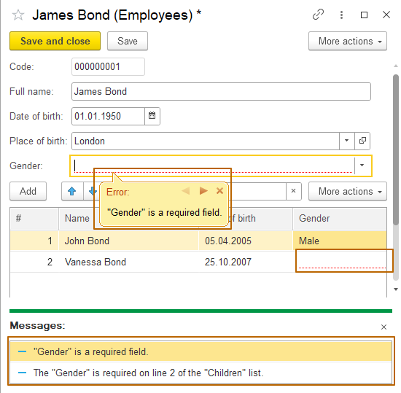

Documents
The Document configuration object is intended to reflect business operations or other events (for example, phone calls to clients) occurring in the organization. Every company has some business processes, such as the production of products, the provision of services or the sale of goods, the hiring and dismissal of an employee, bonus payment at the end of the period, and many others. Even a very small organization consisting of one person has at least several business processes (unless the organization was forgotten immediately after opening).
The main difference between a Document and other metadata objects is that it can be posted. Posting a Document is a reflection of a business operation in the infobase, so until the document is posted, the business operation is not reflected in records, such a document can be considered a draft.
The document is always tied to time. This means that all business operations take place in the actual sequence of events. It allows to control the correctness of the reflection of operations in accounting.
For example, our company is engaged in the manufacture and sale of cakes. John deals with the reflection of transactions in the information system.
On December 1, we made 10 cakes and recorded this operation in the accounting. In the period from 01 to 02 December, we sold all 10 pieces. On December 04, we made 5 more cakes and sold them all on the same day. What if John changes the date of the sales document from 04 to 03 December or if he tries to change the date of the first production document from 01 to 03 December? The system must check the correctness of such transactions, otherwise an accounting error may occur when the company has a negative balance in a certain period of time.
Storing objects of the Document type in the database is similar to storing catalog items: the document itself is stored in one table, and the data of its tabular sections is stored in another.
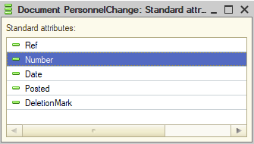
Let's take a look at the standard attributes of a document, there are fewer of them than a catalog. We’ll take a look only at other than catalog attributes:
- Number (number of a document. Depending on the document settings, the number can be checked for uniqueness)
- Date (date and time of a document)
- Posted (an indicator of whether the document has been posted)

Forms
Document contains forms the same as the catalog, only the form of the item (item form) is called the form of the document (document form), and there are also no group and group selection forms.
In the image below:
- valid default forms for the document
- list of all document forms
- document form constructor
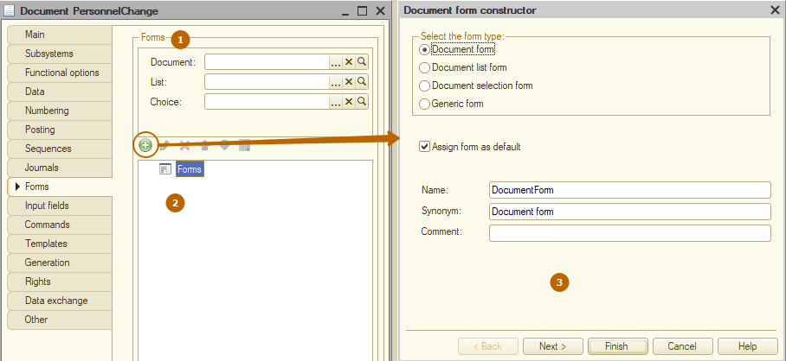

Let’s add some attributes to the “personnel change” document
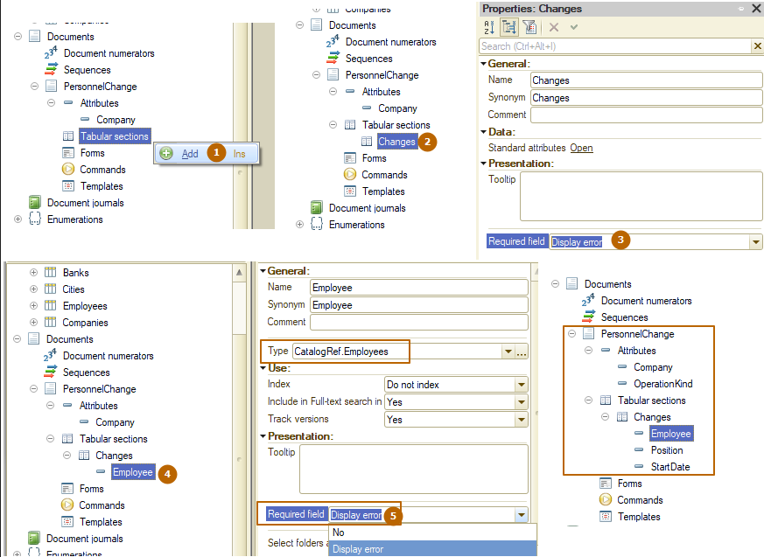
- Add new tabular section Changes
- Go to the property palette of the tabular section
- Select “Display error” value at “Required field” property. Now the platform will not allow us to post a document with an empty tabular section
- Add an “Employee” attribute with type CatalogRef.Employees to the tabular section
- Select “Display error” value at “Required field” property. Now the platform will not allow us to post a document with an empty attribute value in at least one line of the tabular section
There is a way to fill an attribute with a default value when on creating object. Such a value should be specified in the “Default value” property in the property palette of an attribute. For the OperationKind attribute, I will specify the “position changing” value.
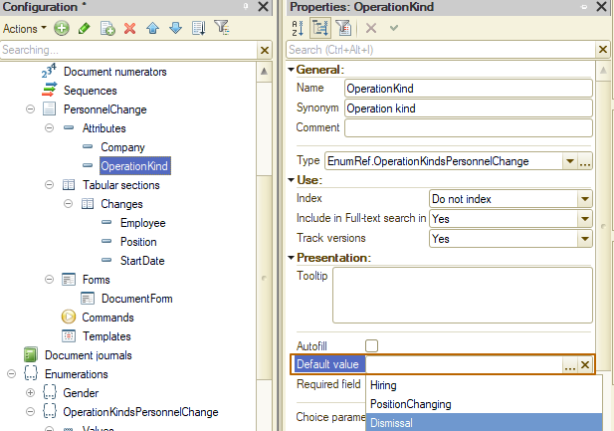

Now let’s create the document form with the form constructor. We can use the "open" button of the Document field of the default forms section. So, the form type will be immediately filled with the correct value, and the "assign form as default" flag will be turned on and unavailable for turning off. In the "Arrange controls in" field change the value to 2 so that the attributes in the form header are displayed in 2 columns.
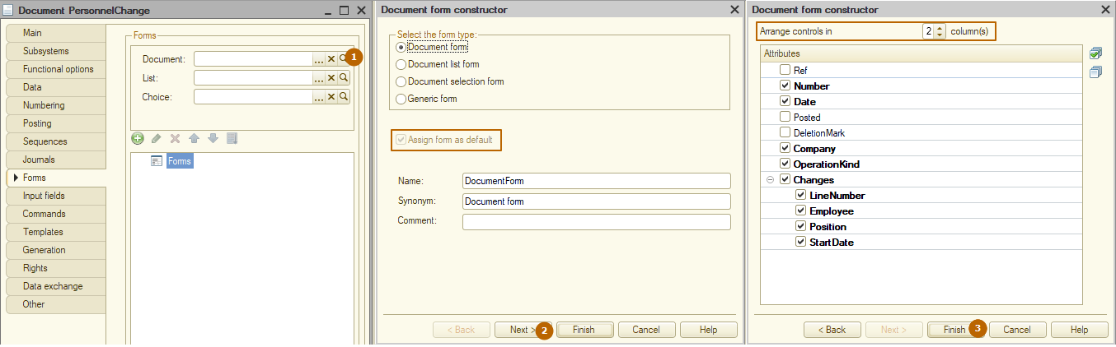

After clicking the "Finish" button, the created form will be opened:
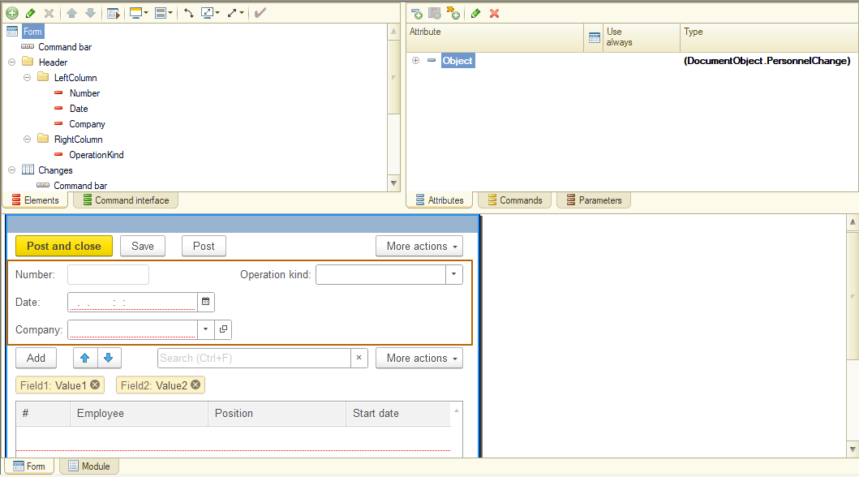
As you can see, the operation kind is located to the right of other elements in the form header. We will cover the details of working with the form in a later lesson. It's time to take a look at the document form in Enterprise mode. You can see that when creating a new document, the value of the OperationKind field is already filled with the default value, and the company field and the Changes tabular section that are required to be filled in are highlighted in red, because they have no values/rows.
